HARIHARAN 24BAD030
MACHINE LEARNING
SCENARIO 1 – MULTINOMIAL NAÏVE BAYES
Problem Statement
Classify SMS messages as Spam or Ham (Not Spam).
Dataset (Kaggle – Public) https://www.kaggle.com/datasets/uciml/sms-spam-collection-dataset
Target Variable: Message Label (Spam / Ham)
Input Feature: SMS Text Messages
IN-LAB TASKS (Multinomial Naïve Bayes)
1. Import required Python libraries.
2. Load the SMS Spam dataset.
3. Perform data preprocessing:
· Text cleaning (lowercase, punctuation removal)
· Stop word removal (optional)
4. Convert text into numerical features using:
· Count Vectorization / TF-IDF
5. Encode target labels.
6. Split dataset into training and testing sets.
7. Train a Multinomial Naïve Bayes classifier.
8. Predict message classes.
9. Evaluate performance using:
· Accuracy
· Precision
· Recall
· F1 Score
10. Analyze misclassified examples.
11. Apply Laplace smoothing and observe impact.
Visualization
• Confusion Matrix
• Feature importance (Top words influencing spam classification)
• Word frequency comparison (Spam vs Ham)
OUTPUT:

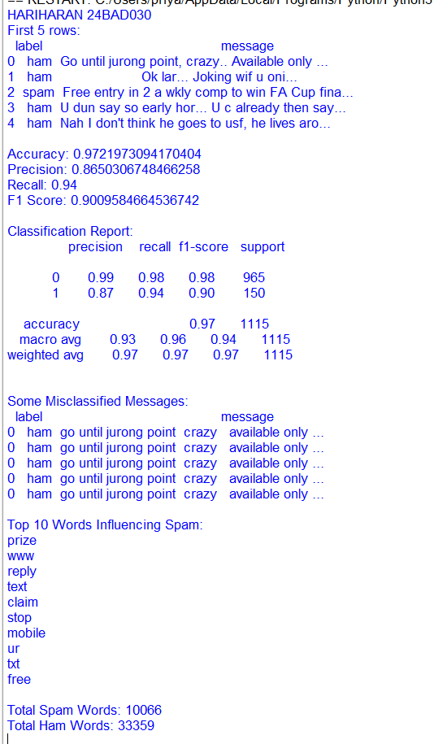
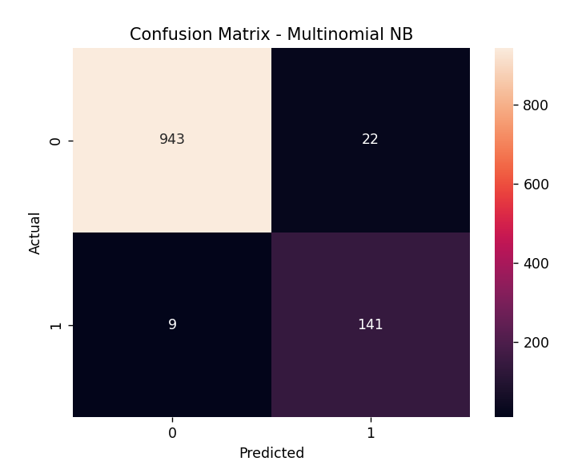
SCENARIO 2 – GAUSSIAN NAÏVE BAYES
Problem Statement
Classify flower species based on physical measurements.
Dataset (Public / Standard Dataset)
Iris Dataset (sklearn)
Target Variable: Flower Species
Input Features
• Sepal Length • Sepal Width • Petal Length • Petal Width
IN-LAB TASKS (Gaussian Naïve Bayes)
1. Import required Python libraries.
2. Load the Iris dataset.
3. Perform data inspection & preprocessing.
4. Apply feature scaling.
5. Split dataset into training and testing sets.
6. Train a Gaussian Naïve Bayes classifier.
7. Predict species labels.
8. Evaluate performance using:
· Accuracy
· Precision / Recall / F1 Score
9. Compare predictions with actual labels.
10. Analyze class probabilities.
11. Compare Gaussian NB with Logistic Regression (optional).
Visualization
• Decision Boundary Plot (using two features)
• Confusion Matrix
• Probability distribution plots
OUTPUT:

